Can Humans See the Cloak? A Perceptual Study of Glaze-Protected AI-Generated Images
Mr. Aryan Gandhi  Third Year Engineering  Vidyalankar Institute of Technology  Mumbai, India  aryan.gandhi@vit.edu.in | Dr. Aniket Kundu  First Year Department  Vidyalankar Institute of Technology  Mumbai, India  mahesh.khandke@vit.edu.in | Prof. Divya Nimbalkar  Computer Science Department  Vidyalankar Institute of Technology  Mumbai, India  divya.nimbalkar@vit.edu.in

Abstract—Glaze protects artists from style mimicry by adding perturbations to images that are meant to be hard for people to see. We test that claim directly with a two-alternative forced-choice (2AFC) perception study. We generated 40 images locally with a Stable Diffusion checkpoint, processed each with Glaze, and built a browser-based quiz that shows participants an original next to its glazed counterpart and asks them to pick the glazed one. Each session draws 10 random pairs and randomizes their left/right placement. Across 15 participants and 150 trials, the glazed image was identified in 48.7% of trials, compared with 50% expected by chance (one-sided binomial test, p = 0.66). We describe the pipeline and quiz system, report detection rates per participant and per image, and discuss what the results imply for the visibility–protection trade-off in adversarial cloaking tools.
Index Terms—adversarial perturbation, Glaze, style mimicry, diffusion models, human perception, two-alternative forced choice

I. INTRODUCTION
Text-to-image diffusion models such as Stable Diffusion [1] can be fine-tuned on a small set of an artist's work to imitate their style. Lightweight methods like LoRA [2] make this cheap, and community platforms host many such style models. This has raised concerns about consent and livelihood among working artists.

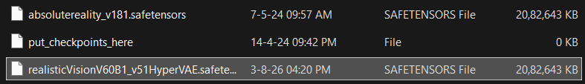
Fig. 1. Models used for generating the images.
Glaze [3] responds by "cloaking" an image: it adds a small, optimized perturbation that shifts how a model's feature extractor perceives the image's style. A model fine-tuned on cloaked images learns a distorted style. For the tool to be usable, the perturbation must also be hard for humans to see, so that artists can post protected work without visibly degrading it.
This paper asks a simple question: can people tell a glazed image from its original when the two are shown side by side? If observers detect the glazed image reliably above chance, the perturbation has a visible cost. If they perform at chance, Glaze meets its imperceptibility goal under these viewing conditions.
Our contributions are:
- A reproducible pipeline that generates images locally, glazes them, and pairs each original with its glazed counterpart by filename.
- A self-contained browser quiz implementing a randomized 2AFC task, with a synchronized magnifier for close inspection and a per-pair results review.
- A perception study measuring human detection rates of Glaze perturbations, reported per participant and per image.
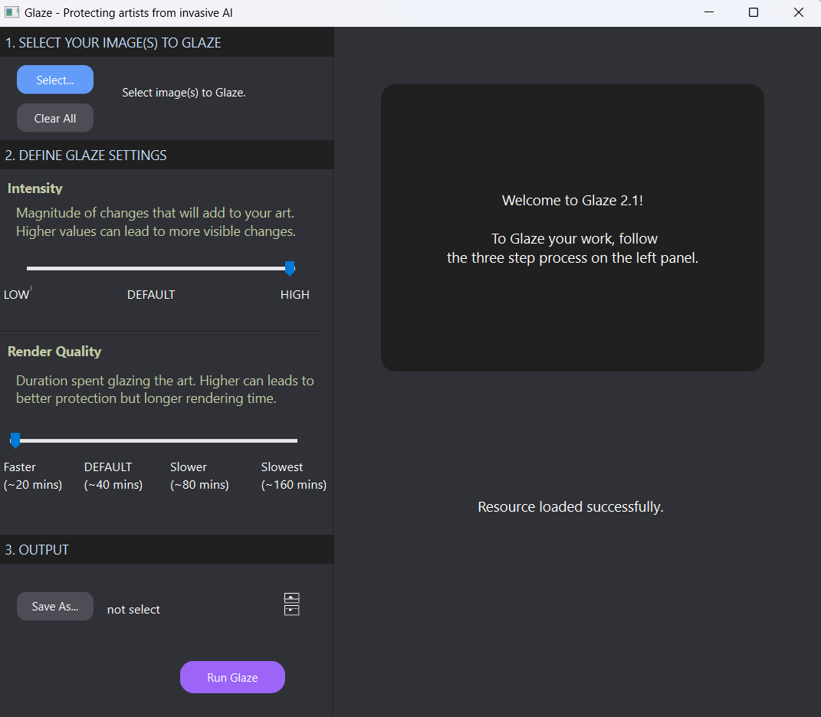
Fig. 2. Glaze tool used for adding perturbations to the images.

II. BACKGROUND AND RELATED WORK
Adversarial perturbations. Szegedy et al. [4] showed that small, carefully chosen changes to an input can flip a neural network's prediction while remaining nearly invisible. Goodfellow et al. [5] explained this as a consequence of the networks' locally linear behavior and introduced the fast gradient sign method. Glaze applies the same principle to style features rather than class labels.
Latent diffusion. Stable Diffusion [1] builds on denoising diffusion [6], running the denoising process in the latent space of an autoencoder that downsamples images by a factor of 8 per side. It was trained on subsets of LAION-5B [7], a web-scraped collection of about 5.85 billion image–text pairs, which is central to debates about consent in training data.
Glaze and Nightshade. Glaze [3] optimizes a perturbation that moves an image toward a target style in a feature extractor's embedding space. It bounds visible change with a perceptual budget based on LPIPS [8], and exposes intensity and render-quality settings that trade visibility against protection. Nightshade [9], from the same group, is a poisoning attack: perturbed images teach a model a wrong association for a concept. This study evaluates Glaze only.
Robustness and perceptibility. Hönig et al. [10] showed that simple preprocessing, such as noisy upscaling, can remove much of the protection offered by several cloaking tools. The original Glaze evaluation included user studies with artists [3]. Our work complements it with a controlled, randomized 2AFC test on AI-generated images rather than artists' own work.

III. SYSTEM DESIGN
The system has three stages: local image generation, glazing, and a browser-based quiz. All stages run on one machine and no images leave it.
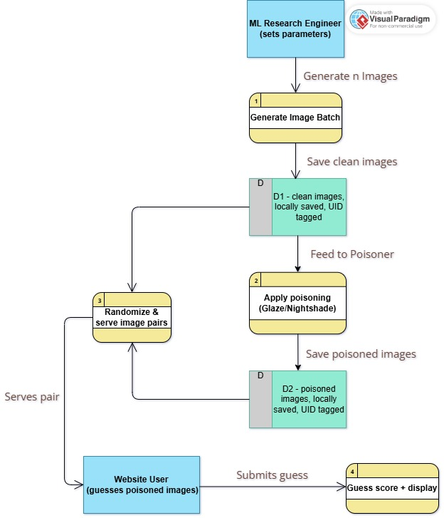
Fig. 3. Data flow of the project, as used by ML engineers.

A. Image Generation
Images were generated in ComfyUI using downloaded from CivitAI . We produced 40 images covering human portraits, scenery images, animals, fantasy images and activity images and added one image captured from a DSLR camera of a plant. Images were kept at their native aspect ratios rather than cropped to a square, since cropping removed compositional detail. Images were saved as either PNGs or JPEGs at the highest possible quality.

B. Glazing
Each original was processed with Glaze [version] at intensity [setting] and render quality [setting]. All format conversion was done before glazing, and no image was resized or recompressed afterwards. This matters because resizing and lossy compression can attenuate adversarial perturbations [10], and a format mismatch within a pair would give observers a non-Glaze cue. Glaze's output keeps the original filename as a prefix, which the quiz uses for pairing.

C. Quiz Application
The quiz is a single HTML file that runs locally in the browser with no server.
- Loading and pairing. The user selects the glazed folder (remembered across sessions in Chromium browsers via the File System Access API) and a set of originals. Each original is matched to the glazed file whose name begins with the original's stem; longer stems are matched first to avoid collisions. Unmatched files are listed and excluded.
- Randomization. Each session samples 10 pairs uniformly without replacement (Fisher–Yates shuffle) and independently assigns the glazed image to the left or right with probability 0.5.
- Adaptive layout. For each pair, the layout that displays the images larger on the current screen is chosen: side by side for portrait and square images, stacked for wide ones. Both images in a pair are always shown at identical size.
- Loupe. On mouse-equipped devices, hovering magnifies the same relative location in both images at 3× simultaneously, allowing direct local comparison.
- Interstitials. After every two pairs, a short factual card about generative AI or image cloaking is shown.
- Results. The final screen reports the score against chance and a per-pair review marking the glazed image and the participant's choice.
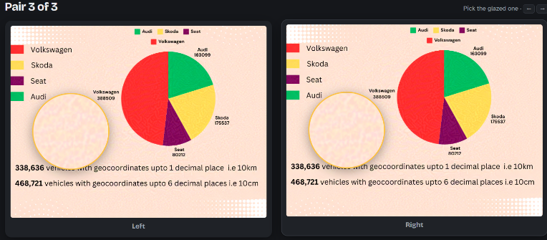
Fig. 4. Quiz trial showing a pair side by side with the loupe active.
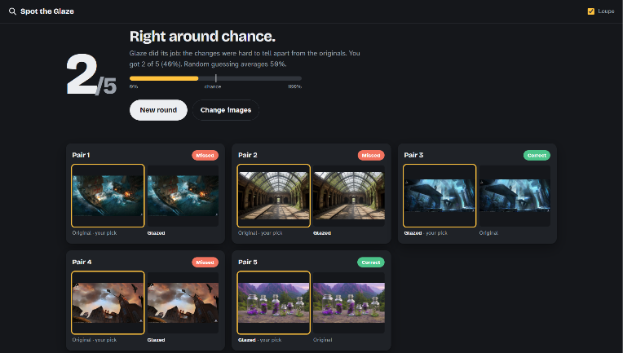
Fig. 5. Results screen showing the score and per-pair review.

IV. METHODOLOGY
Participants. 15 participants took part ([recruitment method, e.g. students and colleagues]; [age range]; [number with art or design background]). None were told the Glaze settings or shown glazed examples beforehand.
Procedure. Each participant completed one session of 10 trials on [device and display, e.g. a 15.6-inch 1920×1080 laptop in a lit room]. On each trial they saw an original and its glazed counterpart and had to choose the image they believed was glazed. There was no time limit, no feedback until the end, and the loupe was [available / disabled]. [State whether participants could repeat sessions and whether repeats were counted.]
Ethical considerations. [State ethics approval or exemption, and how informed consent was obtained.]
Measures. The primary measure is detection accuracy: the proportion of trials in which the glazed image was chosen. We also record accuracy per image, to see whether certain content (for example smooth gradients versus dense texture) makes perturbations more visible.
Analysis. Under the null hypothesis that Glaze is imperceptible, each trial is a fair coin flip, so the number of correct picks k out of n trials follows a binomial distribution with p = 0.5:
P(K ≥ k) = Σ_{i=k}^{n} C(n, i) · 0.5^n (1)
We apply a one-sided binomial test to pooled trials and to each participant's 10 trials, at α = 0.05. With 10 trials per participant, an individual needs at least 9 correct to reach significance (P = 0.011), so per-participant results are reported descriptively and conclusions rest on the pooled test. For the pooled test (n = 150), significance requires at least 86 correct picks (57.3%).

V. RESULTS
Across 150 trials from 15 participants, the glazed image was chosen in 73 trials (48.7%), which is not significantly above chance (one-sided binomial test, p = 0.66; 95% exact CI 40.4%–57.0%).
TABLE I
DETECTION ACCURACY SUMMARY

Measure | Value
Participants | 15
Total trials (15 × 10) | 150
Correct (glazed image chosen) | 73
Pooled accuracy | 48.7%
95% CI for pooled accuracy (exact) | 40.4% – 57.0%
Binomial p-value (one-sided) | 0.66 (0.658)
Mean per-participant score (out of 10) | 4.87 ± [SD: needs per-participant scores]
Participants scoring ≥ 9 of 10 | 7 [to verify; see Section VII]

[Insert Fig. 6 here: per-participant score bar chart, scores out of 10 with dashed line at 5 (chance). Needs per-participant data.]
Fig. 6. Per-participant scores out of 10; dashed line marks chance (5/10).
Detection depended strongly on image content. Images dominated by large smooth regions, such as skies, skin and soft gradients, were the easiest to identify: there the perturbation shows up as faint texture or patterning on an otherwise uniform surface. Highly textured images, such as foliage or detailed fabric, were harder, because the perturbation blends into existing detail. This is consistent with visual masking, where busy texture hides small changes. [Claim needs per-image accuracy data; none was provided.]

Fig. 7. Null distribution of correct picks for n = 150 under H0 (p = 0.5). The observed count k = 73 is marked; the dark bars are the one-sided tail (k ≥ 73) used for p = 0.66. Generated from the reported totals.

VI. DISCUSSION
The side-by-side 2AFC design with a synchronized loupe is a deliberately demanding test. Real viewers usually see a single image with no reference, so detection rates here are an upper bound on how noticeable Glaze is in everyday viewing.
Interpretation. At the tested settings, pooled accuracy was 48.7% (95% CI 40.4%–57.0%). This is consistent with the perturbations being effectively invisible to observers in aggregate, even with direct side-by-side comparison and magnification. However, seven of 15 participants scored 9 or 10 out of 10, which indicates that some observers did detect the glazed image reliably. That pattern cannot be reconciled with the pooled result without further checks (Section VII-C), so the aggregate conclusion should not be generalized to every viewer.

A. Limitations
- Sample size. 15 participants and 10 trials each give limited statistical power, especially per participant. At n = 150, a one-sided test at α = 0.05 has about 31% power to detect a true accuracy of 55% and about 77% power for 60%.
- Single setting. Only one Glaze intensity and render-quality setting was tested, so results do not show how visibility scales with intensity.
- AI-generated images. The images were generated rather than hand-made artwork, which is Glaze's intended use case. Perturbation visibility may differ on real artwork.
- Uncontrolled viewing. Display size, brightness and viewing distance were not controlled, and these affect how visible fine detail is.
- Learning effects. If participants took repeated sessions, they may have learned which cues to look for.

B. Future Work
Natural extensions are testing several Glaze intensities to map a visibility curve, comparing Glaze with Nightshade and with images after common transformations such as recompression, and running a single-image ("is this glazed?") condition that better matches real-world viewing. Logging response time and loupe usage would also show how hard each judgment was.

VII. SELF-REVIEW AND CRITICAL ASSESSMENT
This section critically reviews the study before submission. It states what the design can and cannot support, and lists the data issues that must be resolved. It may be moved to a separate review memo if the target venue does not accept it in the paper.

A. Strengths
The hypothesis is stated before analysis and is falsifiable: chance performance (50%) is the null, and a one-sided test with a fixed α is pre-specified. The pipeline is local and reproducible. Randomizing left/right placement, sampling pairs without replacement, and matching image format before glazing remove the most obvious presentation cues. Reporting the per-participant threshold (9 of 10, P = 0.011) shows the multiple-comparison problem was considered.

B. Weaknesses and Threats to Validity
- Power and precision. The pooled 95% CI (40.4%–57.0%) includes accuracies up to 57%, so the study cannot rule out a modest visible effect. A significant result would require at least 86 of 150 correct picks (57.3%). "Not significant" is not evidence of imperceptibility.
- Non-independence of trials. The pooled binomial test treats all 150 trials as independent, but trials from the same participant share that person's skill and response bias. A participant-level analysis (one-sample test or sign test on the 15 scores, or a mixed-effects model) is more appropriate, and it would capture the heterogeneity noted in Section VI.
- Image-level confounds. Each pair differs in content, so content effects are confounded with pair identity. Per-image accuracy is needed to support the claim in Section V that smooth images are easier to flag; that claim is currently unsupported by data.
- Uncontrolled conditions. Display, lighting and viewing distance were not standardized, and a loupe-enabled 2AFC test is more sensitive than real-world viewing. Results describe an upper bound on detectability, not a typical viewer.
- Convenience sample. Participants' art or design background, which may affect detection, is not yet reported in the paper.

C. Data Consistency Issues to Resolve
- Trial count. Table I originally listed 30 total trials, but 15 participants × 10 trials gives 150, and 73 correct picks cannot come from 30 trials. This paper uses 150. Please confirm.
- Participants scoring ≥ 9. Under the null, P(≥ 9 of 10) = 0.011, so about 0.16 of 15 participants would reach this score by chance. Observing 7 is extremely unlikely under the null (roughly 10⁻¹⁰). If seven participants scored at least 63 correct, the other eight together had at most 10 correct, an average of 1.25 out of 10, well below chance. That pattern suggests either a systematic bias (for example, consistently choosing the original) or an answer-key or logging error. The raw session logs should be checked before submission.
- Missing data. Per-participant scores (needed for the SD and Fig. 6), per-image accuracy (needed for the abstract and Section V), and session counts are not yet available.

D. Assessment of the Conclusion
The pooled result supports the narrower statement that participants were not reliably above chance on average. It does not support the stronger claim that Glaze is imperceptible to all viewers. Showing imperceptibility would require an equivalence test with a pre-specified margin (for example, ±5 percentage points) and a much larger sample. The subgroup pattern in Section VII-C must be resolved first, because it may change which claim the data support.

VIII. CONCLUSION
We built a local pipeline and a randomized side-by-side quiz to measure whether people can see Glaze's protective perturbations. In 150 trials from 15 participants, the glazed image was identified in 48.7% of trials, which is not significantly different from chance (one-sided p = 0.66). A subset of participants nonetheless detected the glazed image reliably, and this must be explained before the result is generalized. The quiz is a single self-contained HTML file, so the study can be repeated with other image sets, Glaze settings or cloaking tools with little effort.

ACKNOWLEDGMENT
[Funding, acknowledgments, and data/code availability link (quiz file, anonymized results) to be provided.]

REFERENCES
[1] R. Rombach, A. Blattmann, D. Lorenz, P. Esser, and B. Ommer, "High-resolution image synthesis with latent diffusion models," in Proc. IEEE/CVF CVPR, 2022.
[2] E. J. Hu et al., "LoRA: Low-rank adaptation of large language models," in Proc. ICLR, 2022.
[3] S. Shan, J. Cryan, E. Wenger, H. Zheng, R. Hanocka, and B. Y. Zhao, "Glaze: Protecting artists from style mimicry by text-to-image models," in Proc. USENIX Security Symposium, 2023.
[4] C. Szegedy, W. Zaremba, I. Sutskever, J. Bruna, D. Erhan, I. Goodfellow, and R. Fergus, "Intriguing properties of neural networks," in Proc. ICLR, 2014.
[5] I. J. Goodfellow, J. Shlens, and C. Szegedy, "Explaining and harnessing adversarial examples," in Proc. ICLR, 2015.
[6] J. Ho, A. Jain, and P. Abbeel, "Denoising diffusion probabilistic models," in Proc. NeurIPS, 2020.
[7] C. Schuhmann et al., "LAION-5B: An open large-scale dataset for training next generation image-text models," in Proc. NeurIPS Datasets and Benchmarks Track, 2022.
[8] R. Zhang, P. Isola, A. A. Efros, E. Shechtman, and O. Wang, "The unreasonable effectiveness of deep features as a perceptual metric," in Proc. IEEE/CVF CVPR, 2018.
[9] S. Shan, W. Ding, J. Passananti, S. Wu, H. Zheng, and B. Y. Zhao, "Nightshade: Prompt-specific poisoning attacks on text-to-image generative models," in Proc. IEEE Symposium on Security and Privacy, 2024.
[10] R. Hönig, J. Rando, N. Carlini, and F. Tramèr, "Adversarial perturbations cannot reliably protect artists from generative AI," arXiv preprint arXiv:[arXiv ID], 2024.

